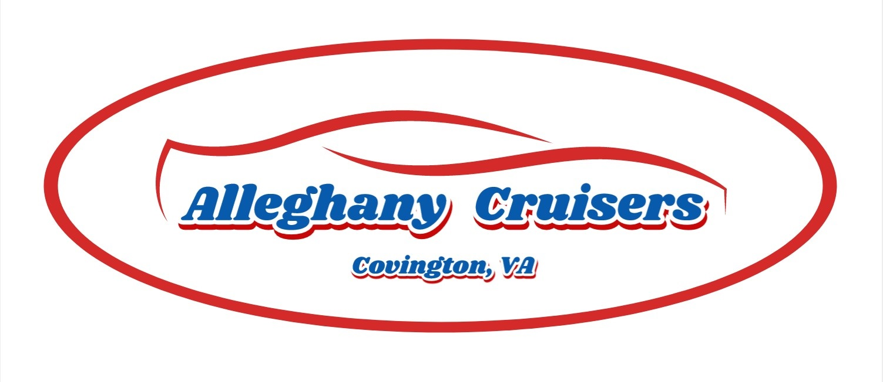

2024-25 BACK THE BLUE CRIMINAL JUSTICE SCHOLARSHIP

Up to two scholarships will be awarded

Guidelines

The Alleghany Cruisers will be presenting two $1,000 scholarships to area high school students wishing to continue their education in a Law Enforcement, Administration of Justice, or related field.

Program Guidelines & Priorities:
* Seeking graduating seniors with a desire to embark on a career in law enforcement, administration of justice, or related field whom intend to continue their education at a higher level.
* Applicants are recommended to have a GPA of 3.0 or higher (consideration will be given to outstanding candidates with lower GPA’s), a total family annual income under $175,000, and plan to attend a 2- or 4-year college or technical school.
* Scholarship funds will be paid at their respective high school’s scholarship awards presentation
* Applicants must have the endorsement of their Guidance Counselor on their application attesting they are a qualified fit for this scholarship program.

Mail one copy of a completed application to The Alleghany Cruisers Inc
P.O. Box 296
Covington VA, 24426

The applications will be reviewed and recipients selected by The Alleghany Cruisers Inc. Applications must be received by not later than April 1, 2025

Scholarship APPLICATION 2023-24

Please enter your answers.
1. | Last Name: | First Name:
2. | Mailing Address  Street:  City: State: Zip:
3. | Daytime Telephone Number: ( )  Email Address:
4. | Date of Birth: Month Day Year Gender:
5. | Cumulative Grade Point Average (GPA): __________ (On a 4.0 scale)  Attach proof of GPA. Your most recent school transcript is required.
6. | Are you the first person in your family to go to college: YES ___ NO ____
7. | Name and location of High School attending:
8. | (If your resume or activities sheet answers question 8, please attach and skip to Question 9.)  A. List any academic honors, awards and membership activities while in high school:  B. List your hobbies, outside interests, extracurricular activities and school related volunteer activities:  C. List your non-school sponsored volunteer activities in the community:
9. | A. If you have decided on what college you will attend, please list school name:  B. If not, list your top 3 college choices:
10. | Name & address of parent(s) or legal guardian(s):  (Include address if different than your own listed in Question 2.)  Name(s):  Street:  City: State: Zip:  Home phone of parents or legal guardians: Work phone:

11

. On a separate sheet please write an essay (250 - 500 words) answering the questions below:

Describe your reasons for wishing to enter a career in law enforcement or administration of justice.

STATEMENT OF ACCURACY FOR STUDENTS

I hereby affirm that all the above stated information provided by me is true and correct to the best of my knowledge. I also consent that if chosen as a scholarship winner my picture may be taken and used to promote the scholarship program. (Winner may waive photo due to unusual or compelling circumstances.)

I hereby understand I will not submit this application without all required attachments and supporting information. Incomplete applications or applications that do not meet eligibility criteria will not be considered for this scholarship.

Signature of scholarship applicant: ___________________________________ Date: ___________________

STATEMENT OF SUPPORT BY GUIDANCE COUNSELOR

I hereby affirm that this application meets the criteria set forth by this scholarship program and that I support this application.

Name of Guidance Counselor submitting the application: ________________________________________________

High School: ___________________________________________________________________________________

Contact information (email and phone): _______________________________________________________________

Signature of Guidance Counselor: ____________________________________ Date: _________________

Checklist

___ Application

___ Essay

___ Resume/Activity Sheet

___ Guidance Counselor signature

REMINDER:
The deadline for this application to be received is
APRIL 1, 2025 NO EXCEPTIONS!

